Pierce College

Michael Wandola
George Njubi

03/19/2021

STEP 3 - PRESENT YOUR FINDINGS AND WORK, IN A 7-MINUTE PRESENTATION.
Screencast URL: http://somup.com/crerfAb3pJ
GitHub URL: https://github.com/GeorgeN01/Final-Presentation-Team

The team members had equal contributions to the project.

STEP 1 - PREPARE A PRESENTATION FOR THE FOLLOWING

1.Feasibility Analysis
- Prepare a SWOT analysis - Strengths, Weaknesses, Opportunities, Threats/Risks, see chapter notes.
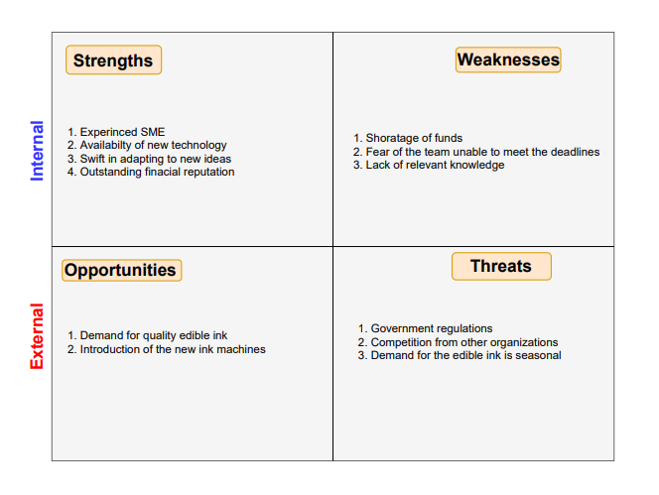

- Complete a Preliminary Investigation Analysis, Complete Steps 1 - 6, see class slides for the outline.

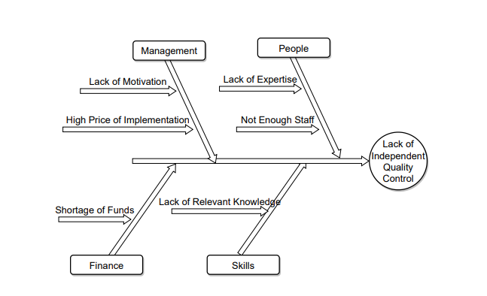
Step 1: Understand the Problem or Opportunity

Step 2: Define the Project Scope and Constraints
Scope of the project
- The project will incorporate the services of the Human Resource department to facilitate recruitment and training.
- The quality control standards will be adopted from the government's quality management board.
- The performance of duties for the project is limited to overseeing activities at the production department and any other duty whose sole purpose is to improve the quality of goods produced.
Constraints
- Training and recruitment of employees to work in the proposed project department can only be done by the Human resource department.
- The approval of the project largely depends on the decision of the top management.
- The employees might sabotage the implementation process if the goals of the project are against the organization's culture.

Step 3: Perform Fact-Finding
Benefits of the project.
- The project will ensure that the organization produces the highest quality of products that meet the industry's expectations.
- The revenue of the organization is expected to increase due to an expected increase in demand for its products.
- The organization is also expected to increase its customer base and improve on brand recognition status.
- Employees and management will be motivated to strive for perfection and quality.
- After separation, the production department's supervision activities are expected to be much more precise and easily coordinated by the officer in charge.
- The customer satisfaction rate is expected to increase.
- Growth in revenue will influence an increase in profitability ratio, which is expected to increase individual share earnings.

Step 4: Analyze Project Usability, Cost, Benefit, and Schedule Data
Cost of establishing and implementing the project.
- Separation of the two departments is expected to cost $150000.
- Training of at least five employees who will be sourced from within the organization $120000.
- Recruitment and training of three employees from without the organization $1200
- Establishment of an office (including furniture and fittings) for quality control department $200000.
- Computers and communication requirements $300000.

Step 5: Evaluate Feasibility

Operational Feasibility
Will it be easier to learn and use?
- We will be using the same system that the employees are used to, so we do not think we will have any operational risk.

Technical Feasibility
Do we have the tech resources?
- We will be using SaaS, so we will not have any issue with technical risk.

Economic Feasibility
Will the benefit exceed the cost?
- We believe that the project's benefit will outweigh the cost, and the project will be fully self-reliant after one financial year.
Schedule Feasibility
Can we do it in time?
- If we will secure the required funds on time, we can deliver the project on time.

Step 6: Present Results and Recommendations to Management

We recommend that Trafina administration pursue the creation of an independent quality control department; although implementing this recommendation will be costly, the benefit will exceed the cost. Some of the benefits of independent quality control are enhanced quality, revenue growth, reduced effort etc.

- Prepare a Preliminary Investigation (STEPS 4/5) Prepare a Feasibility Analysis using the 'Critical Thinking Challenge' provided in this week's module links:

Project Name: Project Trafina
Project Goals:
- To create a new quality control department for the organization.
- Creation of an environment in which, the management and employees strive for quality and perfection.
- Giving the organization a competitive advantage by ensuring that it adopts the latest technology in the market.
Mission:
Providing the community with the best products that satisfy their needs.
Description:
The project seeks to ensure that the organization separates its quality control department from the production department and ensure that the newly formed quality control department adopts the latest technologies in the market. To set the trend for acquisition of new technology in the organization, project Trafina proposes a new ink assessment machine.
Task 1. List of constraints
- Training and recruitment of new employees can only be undertaken by the HR department.
- The approval of the project is largely dependent on the decision of the top management.
- The organization is not able to meet the whole cost of this project.
- Meeting deadlines that have been set for the project has proven to be a challenge.
- Some of the employees might receive the proposed changes with a negative attitude.
- Coordination between project members has proven to a challenging.
- The proposed IT will require an upgrade in the future.
- part of the project's capital will be outsourced, through the finance department.

-
Operational feasibility: Will the goals of the project align with the needs and objectives of the organization? | - The employees lack the skills of operating the new machine that is proposed in the project.
Technical feasibility: Does the organization have the capacity to build the project? | - The current technology at the organization cannot support the needs of the new project.  - There is need to install an office server in future to oversee the all-tech operations.
Scheduling feasibility: Will the project meet the milestones that were set by the team? | - The HR needs to acquire new resources for the training and recruitment of extra employees.  - The team members have had a hard time of meeting the deadlines set for the project.
Economical feasibility: will the benefits of project Trafina outweigh the Total cost of ownership? | - It is estimated that the long-term benefits of the project will outweigh the cost of developing and implementing the project.  - The SME of the project has also pointed out that certifying the current needs of the project will have a huge impact on the company's brand.  - The initial cost of developing the project is high.

- Describe and address the risks associated with each of the feasibility areas.
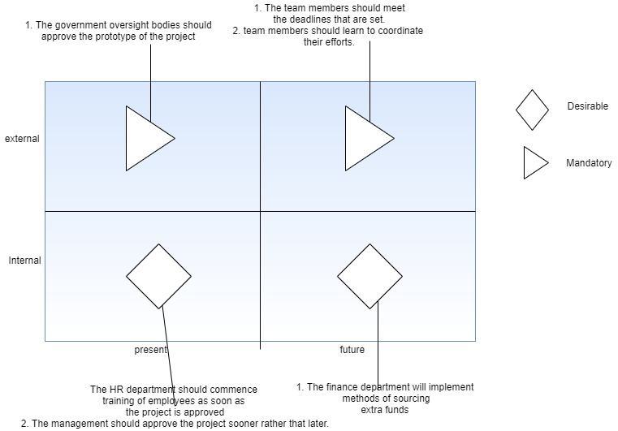

- Project Plan
-Sprint Plan using your User Stories.

- Related tasks (i.e. show the preceding tasks), durations, and Gantt.
-List of project assumptions.
- We will have access to all the resources we need to complete the project, both human and material
- Personnel costs will not increase during the project period.
- All equipment will be in working condition throughout the project cycle.
- The scope of the project will not change throughout the life cycle.
- The overall expenses of day-to-day progress will not increase.
- The vendor will deliver equipment on time.

- Requirements Models.
Use Case Diagram (see pg 189, fig 6-16)

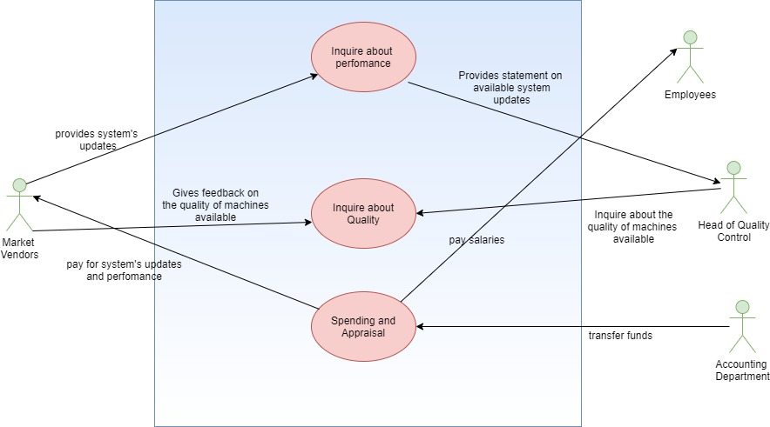

- Data Flow Diagram

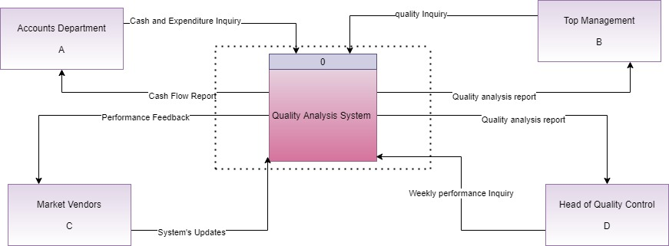
Context Diagram

Project 0

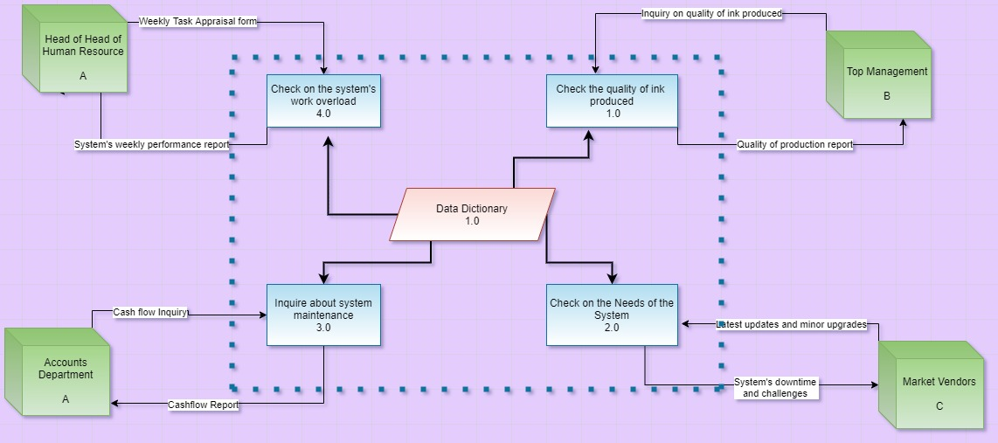

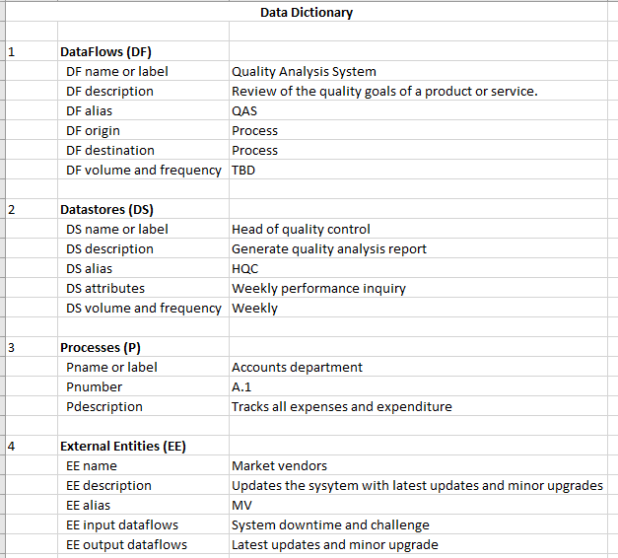

- UML/Object Models
- an object relationship diagram (see pg 186, Fig 6-11)
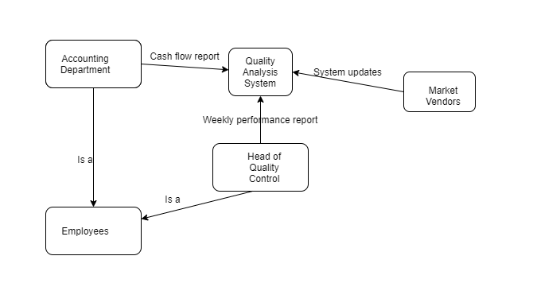

- an activity diagram for a key object/class/person from CIS 210 project (see pg 193, fig 6-22)
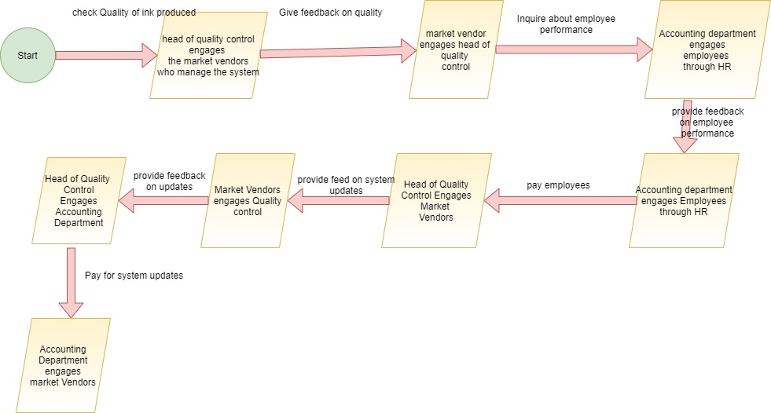

- Sequence diagram (see pg 192, fig 6-20) for one of your use cases selected from your use case diagram above, using the actors you have defined in item 1 above. An actor is a person, place, event or thing (a noun). 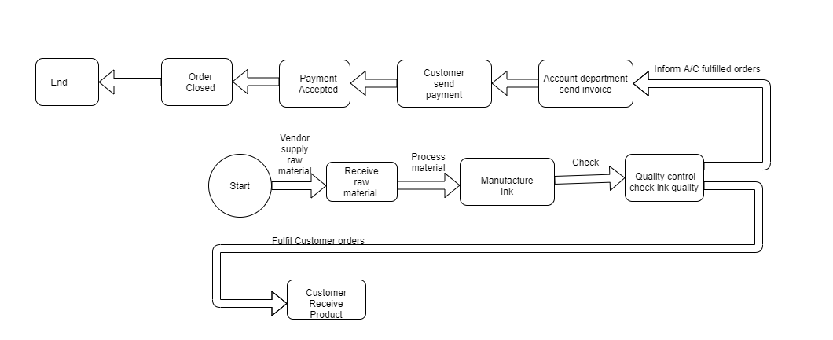

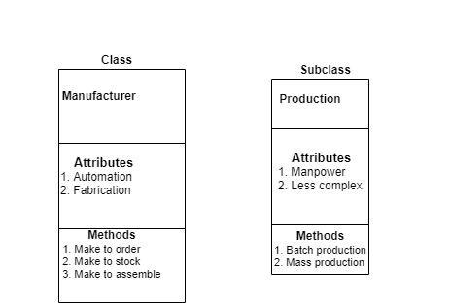
3. Define a superclass/class and subclass with the pertinent non-duplicated attributes example similar to a 'Person's' superclass defined in the textbook. Your subclass should be applicable to your CIS 210 project objects. (see pg 184, fig 6-9) (20 pts)
Subclass
Superclass

Attributes
1.Truck
Methods
1.Logistics
Distribution

STEP 2 - BASED ON YOUR ANALYSIS ABOVE, WRITE AN EXECUTIVE SUMMARY OR ABSTRACT OF THE KEY CONCEPTS AND IDEAS YOU'VE LEARNED IN THIS CLASS.

Abstract

Project trafina is a tech-based project that looks to solve the production problem in an organization. The proposed project will solve the problem of inadequate ink production by introducing a system that monitors the quality of ink produced. The nature of project trafina includes a physical machine, the quality control machine, and software installed to the device and link to different departments of the organization with servers.

This document presents a compilation of all the significant parts that describe project trafina:
- Feasibility Analysis
- Project Plan
- Requirements Models
- Data Flow Diagram
- UML/Object Models

The feasibility analysis focuses on the SWOT analysis of the project to understand both the project's weaknesses and strengths. It is also important to note that the SWOT analysis includes both the external and the internal environment of the organization. Both settings portray their strength and weaknesses and how they can affect the adequate performance of the organization.

The feasibility analysis also includes the preliminary investigation studies, which use the fishbone diagram to trace their root source problems. One of the most significant advantages of the fishbone diagram is that it pinpoints the root cause of a problem in an organization. This project has identified the lack of an independent quality control department as a significant setback; implementing this project will solve this deficiency.

Requirements models

The requirements models that were adopted by this project include the Gantt charts and the sprint plan. The sprint plan is used to monitor and ensure that all the project's activities and ran are implemented successfully.

The Project Plan

The Project plan is an introduction to the project and a summation of the project's objectives and constraints. By going through the project plan, one should be able to have an overview of the whole project. This sprint plan aims to ensure that the new machine is utilized by the organization as soon as possible.

The Data Flow Diagrams

The data flow diagram shows how information flows from the system to the actors and back to the system to complete a full circle of inquiry and feedback. It is a tool that aids communication through the flow of data. This project has four major players who provide and receive information from the system.

The Use Case Diagrams

The use case is a physical representation of the interaction between the system and actors. From what we have gathered so far, the significant difference between a use case diagram and a data flow diagram is that the former is used to display data flow. In contrast, the use case is used to show the interaction between the system and the outsiders. For this project, we have introduced four actors who interact closely with the system. It is also important to note that the project has a data dictionary.

STEP 3 - PRESENT YOUR FINDINGS AND WORK, IN A 7-MINUTE PRESENTATION.

Screencast URL: http://somup.com/crerfAb3pJ
GitHub URL: https://github.com/GeorgeN01/Final-Presentation-Team

